Contact: Eleanor Holmes  Primal Treestands, Inc.  Phone 720-379-6030  Fax 720-379-6050  eleanorm@primalvantage.com | 2407 W. Euclid Ave.  Littleton, CO 80120 | Primal Treestands, Inc.

Press Release

The Safe, Sturdy, and Quiet Way to Hunt!

The Primal Treestands 22’ Mac Daddy Xtra Wide Deluxe Ladderstand
Littleton, CO, February 21, 2019: The Primal Tree Stands Mac Daddy Xtra Wide Deluxe is a durable, rock-solid stand that offers the comfort and stability you need for hunting at lofty heights. Its flip-up mesh seat and foot platform are large enough to get comfortable, allowing you to stay alert and ready for that perfect shot. Simply put, the Mac Daddy Xtra Wide Deluxe has all the amenities you need for a price that won't blow your bucks.
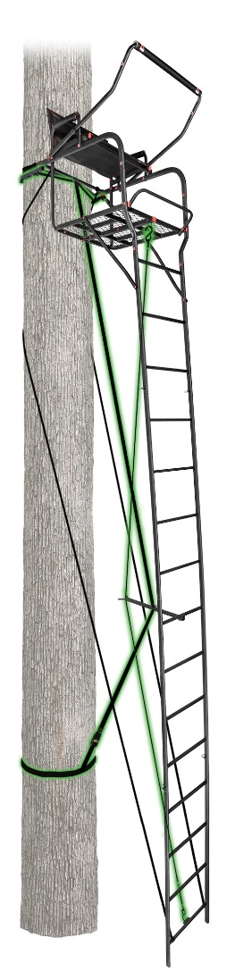
JAW AND TRUSS STABILIZER SYSTEMS: THE SAFE, STURDY, AND QUIET WAY TO HUNT
Safety is always our top priority. That's why you need a ladder stand from Primal Tree Stands. Thanks to our Patented, innovative Grip Jaw and Truss Stabilizer systems, your stand is locked tight to the tree before you ever leave the ground. Plus, the Truss Stabilizer strap allows the stand to be used where others cannot. This innovative technology makes set up extremely safe and gives you a quiet, rock solid stand that can be placed on almost any tree.
- Stabilizer truss system for enhanced ladder strength and stability – eliminates squeaks and creaks!
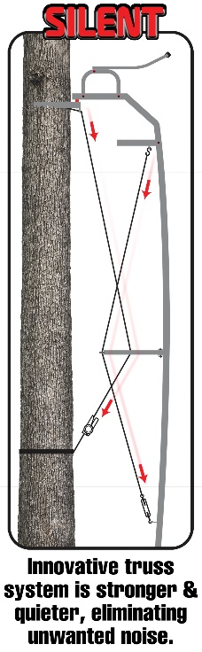
- Primal Tree Stands Grip Jaw system provides sure-grip installation
- 24" x 16.5" extra wide seat platform with premium mesh seat that flips up
- 29.1" x 24” foot platform for added space
- Padded, flip-up adjustable shooting rail
- Padded Armrests are covered with durable, nylon fabric
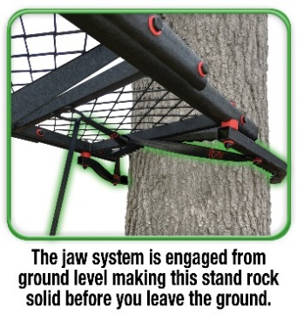
- Sturdy, steel construction with rounded tubing for better grip

