**SCHRECK WHOLESALE, INC.**

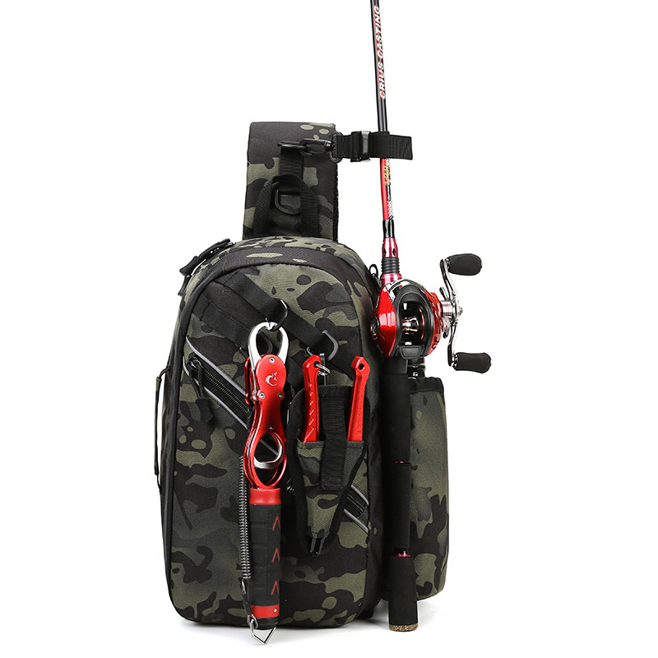**FISHING SLING 1**

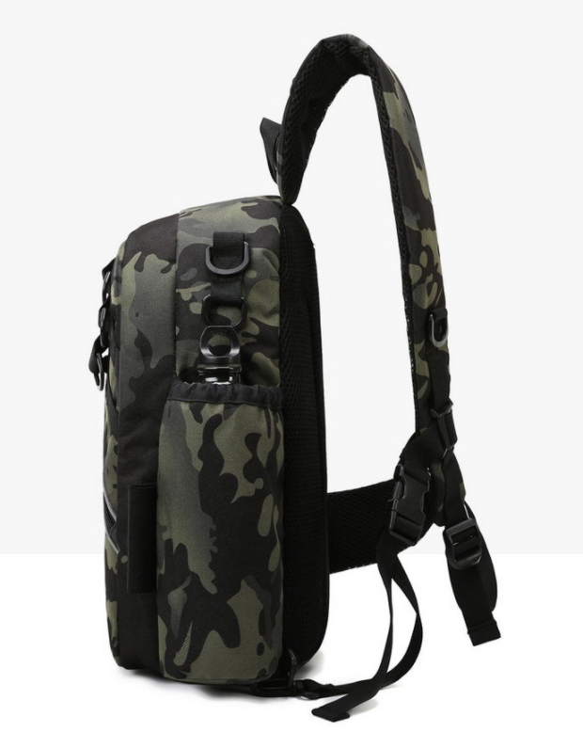

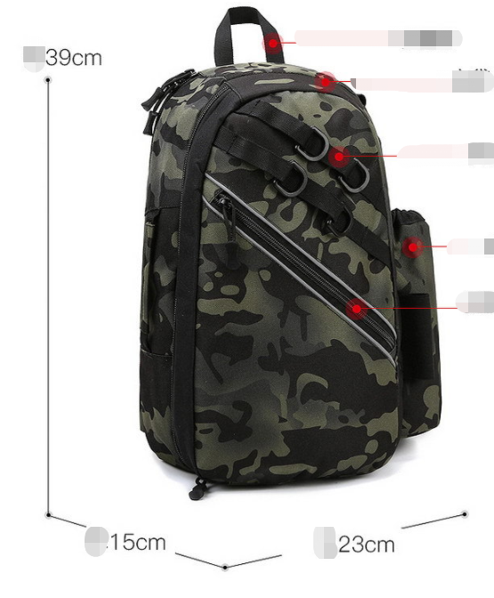

* The size of fishing sling is 39*23*15cm
* Material:600D polyester coated PVC
* Price: $23.00
* MOQ: 600