SCHRECK WHOLESALE, INC.
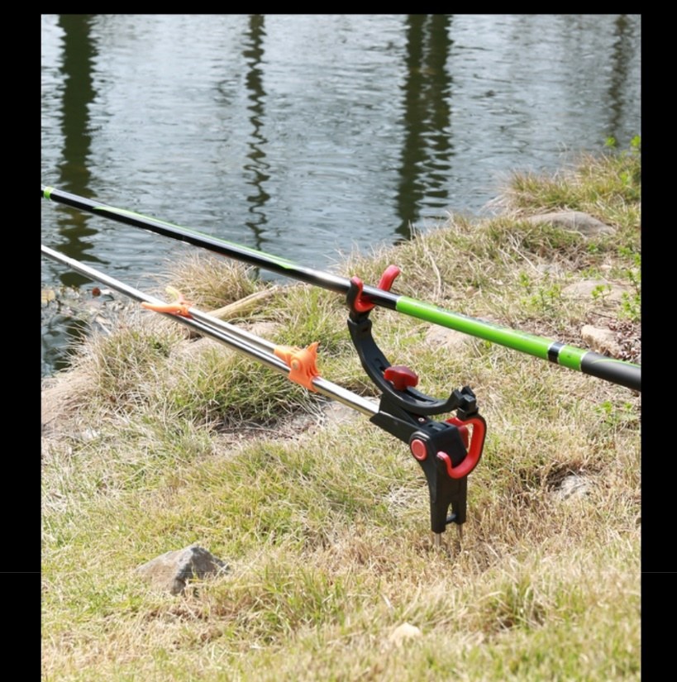
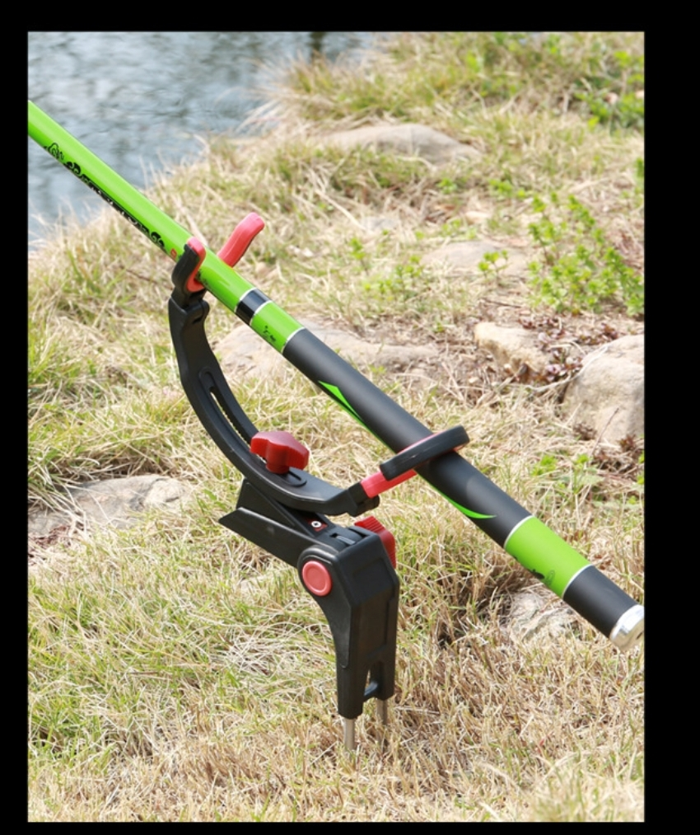
- Fishing Rod Stand
- Stainless Steel
- MOQ: 600
- Single: $10.00
- Double: $13.00

